Beast Report - 21 August 2016 Dave Botherway

Usual welcome: Usual attendees . . .

Buying:

Discussion of eBay ‘Make-on-Offer’ method ( buying a Headlamp)

Questions answered were :

Delays in getting the Win-10 Anniversary Update, supposedly available from 2-August – but may be spread out over next three months

How to change the Date Format (from mm/dd/yy to dd/mm/yy)

Update to Win-10 changing layout of icons on the Desktop, and addition of Cortana searching

Handling of special characters in Eudora email replies ex DaveB.

Background information re forthcoming MelbPC SGM to remove President

Australian Census – progress, penalties ?

Scam warnings :
- Further examples shown, including Australia Post Parcel pickups – but originating from Youlanda-AUSPOST lilittlwdub@mail.ru, ie Russia ? ?

Main Topic
- Macrium Reflect - Tutorial Demonstration

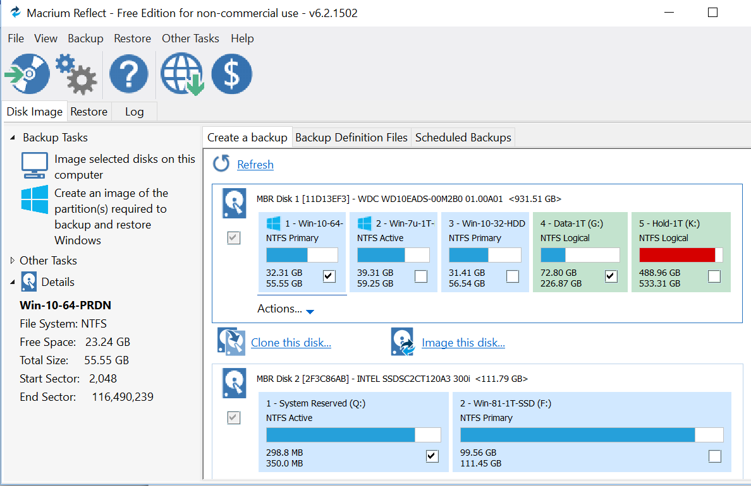

For home use, Reflect is free – and has many advantages over Windows methods
- Output image can be ‘mounted’ as a virtual drive
- Can restore individual files/directories rather than the whole partition

Next Month - Windows 10 progress / issues ? etc . . .

